

Undergraduate Internship Report
Program: Bachelor of Engineering
Department: Computer Science and Engineering
Academic Year: 2022 – 2026

Internship Duration: MAY 2025- AUGUST 2025
Name of Student: Dasara Sai Ram
Register Number: 192210258
Batch: 2022 – 2026
Internship Organization: Codec Technologies
Supervisor in Company: Dr. Anurag Srivastava

1. Internship Completion Certificate
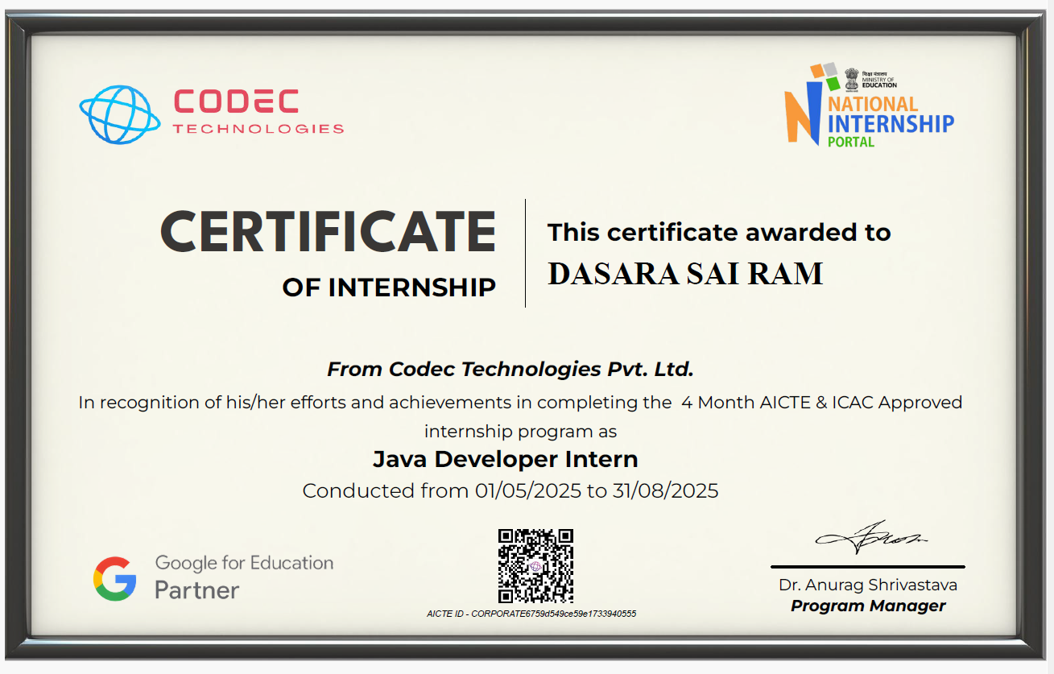

2. Student Declaration

I Dasara Sai Ram, a student of Bachelor of Engineering in the Department of Computer Science and Engineering, solemnly affirm that the internship experience documented in this report reflects my direct involvement in a formal organizational setting, actively engaged in industry-relevant operations.

During the internship period from 01/05/2025 to 31/08/2025, I was entrusted with tasks and responsibilities that were integral to the company’s ongoing functions. The insights and observations included herein are a true representation of the work culture, technical exposure, and professional interactions I encountered.

This report has been prepared based on actual experiences and contributions during my time with the organization. I have abided by the professional conduct expected of an intern and ensured that the contents of this document are factual, original, and aligned with the intended academic and industrial learning objectives.

Signature of the Student
Date: __________

3. Company Overview
Name of the Company:
CODEC Technologies
Nature of Business / Industry Sector: : Online Education & Technology Training
Brief History & Overview:
CODEC Technologies is an online learning and internship platform that provides practical training opportunities for students in various technical domains such as Web Development, Data Science, Artificial Intelligence, and Software Development. The organization focuses on improving students’ technical knowledge by offering hands-on project experience, industry-relevant training, and mentorship support. Through structured internship programs, CODEC Technologies helps students develop real-world skills and gain exposure to modern development technologies used in the software industry.
Key areas of Work
- Backend Application Development – Designing and implementing backend modules using Core Java, focusing on object-oriented programming concepts such as inheritance, polymorphism, exception handling, and collections.
- Database Connectivity – Working with JDBC to establish connections with relational databases, performing CRUD operations, and ensuring secure and efficient data handling.
- Web Application Development with Java – Building dynamic web applications using Servlets and JSP, handling HTTP requests/responses, and managing session data.
- Framework-Based Development – Developing scalable applications using Spring Boot, including RESTful API creation, dependency injection, and modular service design.
- Project Documentation and Learning – Documenting backend workflows, maintaining proper code structure, and following industry-standard practices for version control (Git/GitHub) and collaborative development.
4. Internship Role and Objectives
Internship Title/Designation:
Java Developer Intern
Objectives:
The primary objective of this internship was to gain a comprehensive and practical understanding of Java programming and backend application development. Java is one of the most widely used programming languages in the software industry, powering enterprise systems, web applications, and mobile platforms. By immersing myself in Java development, I aimed to strengthen my foundation in object-oriented programming (OOP) concepts such as encapsulation, inheritance, polymorphism, and abstraction, while also learning how these principles are applied in real-world projects.
A major goal was to acquire hands-on experience with Java-based technologies and frameworks. This included working with JDBC for database connectivity, where I learned to establish secure connections, execute queries, and manage transactions. I also explored Servlets and JSP to build dynamic web applications capable of handling HTTP requests and generating interactive responses. Furthermore, I gained exposure to Spring Boot, a modern Java framework that simplifies backend development by providing built-in support for dependency injection, RESTful API creation, and microservice architecture. These tools allowed me to design scalable and maintainable applications that reflect industry standards.
Another important objective was to understand the complete Software Development Life Cycle (SDLC) from a backend perspective. I participated in requirement analysis, system design, coding, testing, and deployment activities. This gave me practical insight into how backend systems are planned, structured, and integrated with frontend interfaces. I learned how to design modular architectures, manage project files effectively, and ensure that applications meet both functional and non-functional requirements such as performance, security, and scalability.
Developing problem-solving and debugging skills was a critical focus throughout the internship. Backend development often involves handling complex logic, concurrency issues, and database errors. By using IDE debuggers, logging frameworks, and systematic testing approaches, I improved my ability to identify root causes, resolve exceptions, and optimize code performance. This not only enhanced the reliability of my applications but also built confidence in tackling challenging technical problems.
The internship also emphasized collaborative workflows and industry practices. I worked with version control systems such as Git and GitHub to manage code changes, create branches, and resolve merge conflicts. Agile methodology and SCRUM practices were followed, including daily stand-ups, sprint planning, and retrospectives. These experiences taught me how professional teams coordinate tasks, incorporate client feedback, and deliver incremental improvements in a structured manner.
Another objective was to focus on clean coding practices and documentation. I learned to write modular, reusable, and well-commented code that adheres to industry conventions. Documentation was maintained for each module, including JSDoc comments and README files, ensuring that my work was understandable and maintainable by other developers. This discipline reinforced the importance of long-term sustainability in software projects.
Performance optimization was also a key learning area. I explored techniques such as query optimization, caching, and efficient resource management to ensure that backend systems could handle multiple requests without degradation. Understanding how to balance speed, scalability, and reliability was crucial in preparing for real-world enterprise applications.
Finally, the internship encouraged a mindset of continuous learning and adaptability. With Java constantly evolving through new versions, frameworks, and libraries, I recognized the importance of staying updated with modern practices such as microservices, API-driven development, and cloud integration. This objective reinforced the need for lifelong learning, adaptability, and innovation to remain competitive in the fast-changing software industry.
5. Technologies & Tools
During my internship as a Java Developer Intern at Codec Technologies, I had the opportunity to work extensively with a wide range of backend technologies, frameworks, and tools that are widely used in the software development industry today. This experience provided me with a strong practical foundation in Java programming and backend application development, allowing me to apply theoretical knowledge to real-world projects. The tools and technologies I used not only enhanced my technical skills but also improved my ability to design, implement, and maintain scalable, secure, and efficient backend systems. Exposure to industry-standard practices helped me understand how professional development workflows operate in real-time environments. This section elaborates in detail on the various backend technologies I worked with and how each contributed to my learning and development during the internship.
Core Java
The foundation of my internship work was Core Java, which served as the backbone for all backend modules I developed. I gained proficiency in object-oriented programming (OOP) concepts such as encapsulation, inheritance, polymorphism, and abstraction. I also worked extensively with Java Collections (Array List, HashMap, HashSet, LinkedList), exception handling, and multithreading. These concepts allowed me to build robust and reusable components. I learned how to write modular code, manage resources efficiently, and implement business logic in a structured manner.
JDBC (Java Database Connectivity)
A major part of my work involved JDBC, which enabled me to connect Java applications with relational databases. I practiced writing SQL queries, performing CRUD operations, and managing transactions. I learned how to establish secure connections, handle exceptions during database operations, and optimize queries for performance. This experience gave me a clear understanding of how backend systems interact with databases to store and retrieve information.
Servlets and JSP
I explored Servlets and JSP (Java Server Pages) to build dynamic web applications. Servlets helped me handle HTTP requests and responses, while JSP allowed me to embed Java code within HTML to generate dynamic content. I implemented features such as login authentication, form handling, and session management. This gave me practical exposure to how server-side applications process client requests and deliver responses in real time.
Spring Boot Framework
One of the most significant technologies I worked with was Spring Boot, a powerful Java framework for building enterprise-grade applications. I learned how to use dependency injection, configure RESTful APIs, and design modular services. Spring Boot simplified application setup and allowed me to focus on business logic rather than boilerplate code. I also explored concepts such as controllers, services, repositories, and configuration files. This framework introduced me to microservice architecture and modern backend development practices.
RESTful API Development
Using Spring Boot, I gained hands-on experience in RESTful API development. I created endpoints for user authentication, data retrieval, and CRUD operations. I learned how to handle JSON data, manage request/response objects, and implement proper error handling. This experience helped me understand how APIs act as bridges between frontend applications and backend systems.
Version Control with Git/GitHub
Collaboration and code management were facilitated through Git and GitHub. I learned how to create branches, commit changes, push code to repositories, and resolve merge conflicts. Code reviews and pull requests were part of the workflow, which improved my coding discipline and taught me the importance of documentation and teamwork.
IDEs and Development Tools
I used IntelliJ IDEA and Eclipse IDE for writing and managing Java code. These IDEs provided features such as debugging tools, code completion, and integrated build systems, which improved my productivity. I also worked with Maven for dependency management and project builds, ensuring that applications were properly structured and easy to maintain.
Debugging and Testing
Debugging was an essential part of my internship. I used IDE debuggers, logging frameworks (Log4j), and JUnit for unit testing. These tools helped me identify logical errors, optimize performance, and ensure that applications functioned correctly. I also learned how to write test cases to validate modules and maintain code reliability.
Collaboration Tools
To stay aligned with project requirements, I used Trello and GitHub Projects for task management. These tools helped track progress, assign responsibilities, and maintain transparency across the team. I also participated in Agile practices such as daily stand-ups, sprint planning, and retrospectives, which improved my organizational discipline and professional accountability.
Clean Code Practices
Another important aspect of my internship was learning how to write clean and maintainable code. I followed best practices such as proper indentation, meaningful variable names, modular design, and consistent documentation. I also used tools like Checkstyle and SonarLint to enforce coding standards and improve code quality.

6. Learning Outcomes
The internship experience at Codec Technologies was transformative, offering me in-depth exposure to the inner workings of a real-time Java-based software development environment. One of the most significant outcomes was the extensive exposure to the Software Development Life Cycle (SDLC), which included phases such as requirement gathering, designing scalable backend solutions, coding modules in Java, testing functionalities, debugging issues, and preparing components for deployment. This hands-on experience provided clarity on how enterprise-level applications are developed in industry settings, which are far more dynamic and fast-paced compared to academic assignments. I gained a better appreciation of the iterative development model and how client feedback is incorporated throughout the project lifecycle.
A particularly enriching aspect was the use of Agile methodology and SCRUM practices. Daily stand-up meetings, sprint planning, and retrospectives gave me practical insight into how modern backend development teams stay coordinated and productive. I learned how each sprint incrementally builds the product, and how breaking large tasks into smaller modules ensures deadlines are met without compromising quality. Agile also helped me understand the importance of adaptability, client feedback, and the value of a team-driven development model. Working with task boards and sprint workflows using tools like Trello and GitHub Projects improved my organizational discipline and accountability.
From a technical perspective, this internship significantly enhanced my proficiency in Java backend development. I developed strong command over Core Java concepts such as OOP principles, exception handling, collections, and multithreading. I gained practical experience with JDBC for database connectivity, performing CRUD operations, and managing transactions. I also worked with Servlets and JSP to build dynamic web applications and explored Spring Boot to design RESTful APIs, manage dependencies, and implement microservice-based architectures. This hands-on coding experience went far beyond classroom learning and equipped me with the ability to build scalable, secure, and functional backend systems independently.
One of the most insightful outcomes was gaining a strong understanding of how industrial workflows function in backend software development ecosystems. Unlike academic projects, where assignments are often executed in isolation, real-time projects in a corporate setting demand structured, well-documented, and collaborative approaches. My experience working within the Java Development Division gave me practical exposure to how professional teams operate, plan, and execute large-scale software projects using industry-standard tools and frameworks.
At the core of the workflow was task assignment and tracking, managed using project management tools such as Trello and GitHub Projects. These platforms helped divide project requirements into manageable tasks, each tagged with clear objectives, deadlines, and priorities. Boards with swimlanes such as “To Do,” “In Progress,” “Review,” and “Done” were used to track the flow of work. This not only gave clarity on my individual responsibilities but also enabled transparency across the team. Regular updates were maintained for each card, helping mentors and team members assess progress without constant follow-ups. I learned how breaking down high-level goals into microtasks helps avoid bottlenecks and ensures steady progress.
A major part of our collaborative workflow was the use of version control systems, primarily Git and GitHub. Initially, managing version control in a team setting posed a steep learning curve. However, with guidance from senior developers, I became proficient in using Git commands and understanding workflows involving branches, forks, merge requests, and pull requests. I learned to create feature-specific branches, test code locally, and push it to remote repositories after proper documentation. Code reviews were an integral part of this system, where every pushed change was subject to scrutiny and feedback by team leads. Through these reviews, I not only improved my code quality but also developed a habit of writing cleaner, well-commented, and modular code. I also learned how merge conflicts are resolved and how GitHub’s comparison viewer assists in spotting code differences during integration.
Additionally, code review and feedback sessions provided a platform for continuous learning. These sessions allowed me to understand coding patterns, optimization strategies, and real-world logic that go beyond textbook approaches. They cultivated a habit of accepting constructive criticism and understanding the rationale behind each suggested improvement. Sprint planning and review meetings were held at the beginning and end of every cycle, where completed tasks were evaluated, upcoming goals were discussed, and challenges were addressed. These iterative discussions helped me understand Agile methodology in depth and exposed me to real-time SCRUM practices, which are now widely adopted across software industries globally.
Another critical aspect of industrial workflow I experienced was the emphasis on clean code practices and documentation. Each function, module, or component I developed had to be easily understandable and reusable. I was expected to follow the company’s style guidelines for naming conventions, indentation, and modularity. This was essential not only for code maintainability but also to ensure that others on the team could build upon or debug the modules I created. We were encouraged to write Javadoc comments for functions and include detailed README files when delivering standalone modules. This discipline helped me understand that writing code is only one part of the job—making it understandable and maintainable is equally important.
Feedback from Supervisor:

The feedback from my supervisor reflected the progress I made throughout the internship. I was appreciated for proactively resolving technical issues, demonstrating a willingness to explore solutions independently, and maintaining a positive attitude even in complex situations. My supervisor commended my growth in collaboration and communication, especially my ability to work effectively in a team setting using GitHub. I received encouraging feedback on the quality, consistency, and structure of my code, which had improved significantly by the end of the internship.
7. Software Development Life Cycle (SDLC) Followed During Internship

During my internship, I gained practical exposure to the Software Development Life Cycle (SDLC) as applied to backend Java projects. Each phase of the cycle was followed systematically, helping me understand how enterprise-level applications are planned, developed, tested, and maintained in real-world environments.

- Requirement Analysis – In this phase, the requirements of the backend application were clearly identified. I understood the purpose of the project, analysed the target users, and documented the necessary features such as login authentication, database CRUD operations, RESTful API endpoints, and error handling. Both functional requirements (data processing, API responses) and non-functional requirements (performance, scalability, security) were considered to ensure clarity before starting development.
- System Design – After analysing the requirements, the system design phase was carried out. This involved planning the overall architecture of the application, including database schema design, class diagrams, and module structures. I worked on designing layered architectures with controllers, services, and repositories, ensuring modularity and maintainability. The focus was on creating a clean, scalable, and efficient backend structure that could integrate seamlessly with frontend interfaces.
- Implementation (Coding Phase) – This phase involved the actual development of the application using Core Java, JDBC, Servlets, JSP, and Spring Boot. I implemented modules for user authentication, session management, and database connectivity. RESTful APIs were developed to handle client requests and deliver JSON responses. I practiced writing structured, reusable code, organizing project files properly, and ensuring that the application functioned correctly according to the requirements.
- Testing Phase – In the testing phase, the application was evaluated to ensure correctness and reliability. I performed unit testing using JUnit, validated API endpoints, and checked database transactions. Debugging tools within IntelliJ IDEA and logging frameworks such as Log4j were used to identify and resolve errors. Functional testing verified that modules such as login, registration, and data retrieval worked as expected. Performance testing was also conducted to ensure the application could handle multiple requests efficiently.
- Deployment and Maintenance – Although the internship mainly focused on development activities, I gained basic knowledge about deployment practices and version control systems. I learned how developers use Git and GitHub to manage code, track changes, and maintain project versions. I also explored how applications are deployed on servers, configured with databases, and updated through iterative releases. This phase emphasized the importance of proper documentation, collaboration, and continuous maintenance in real-world software development environments.

8. Implementation Results

During my internship, I developed a Student Management System using Java, JDBC, Servlets, JSP, and MySQL. The project was designed to manage student records, course enrolments, and performance tracking. It provided a backend-driven solution for handling student data securely and efficiently.

Code Implementation:
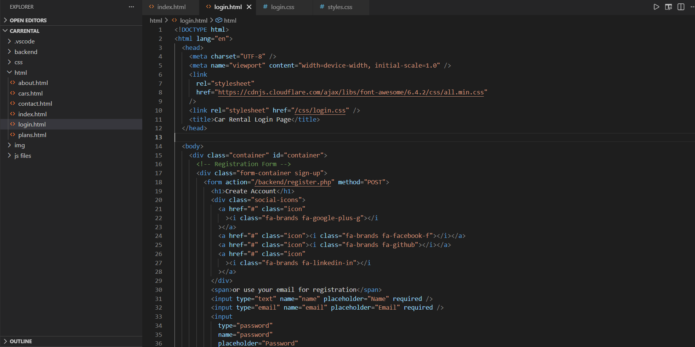

Login Page:

Implemented secure login authentication using Servlets and JDBC. The system validated user credentials against the database and provided role-based access for admin and students.

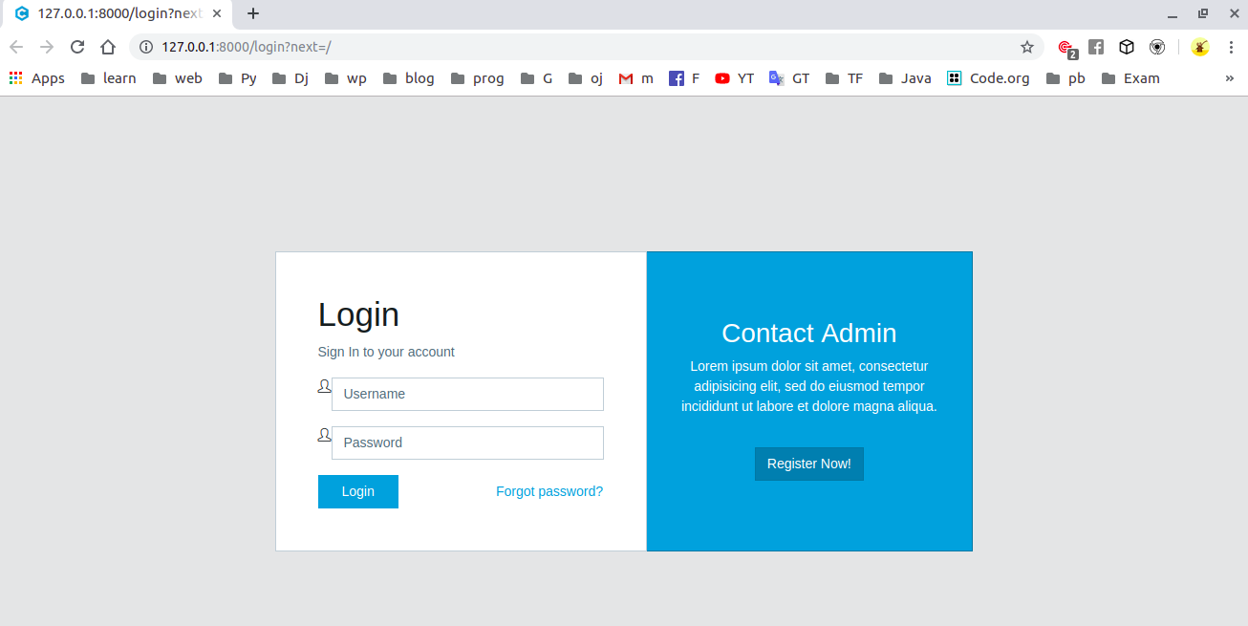
Home Page:

Designed a dashboard that displayed student details, courses, and quick navigation options. Integrated backend logic to fetch records dynamically from the database.

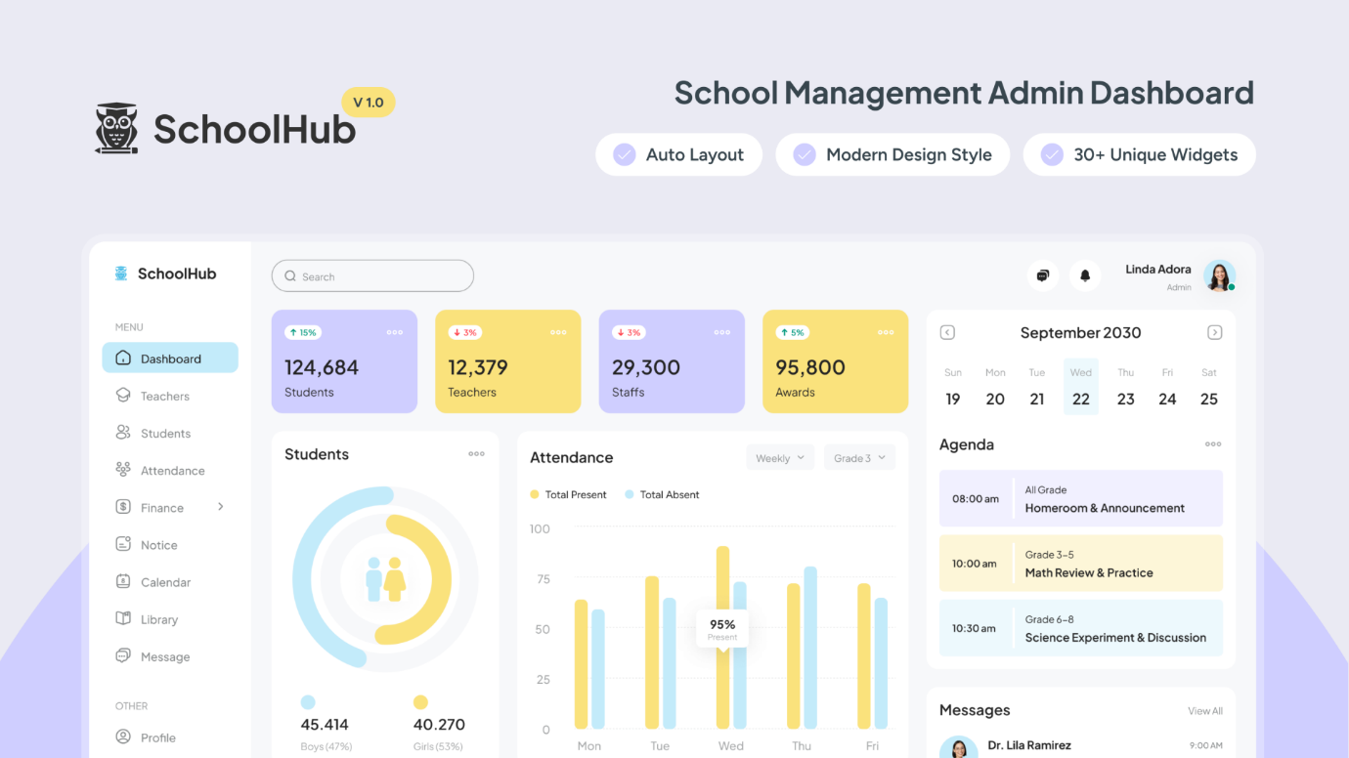

Add Student Form :

Created a form to register new students with fields such as name, roll number, course, and contact details. Data was stored in the database using JDBC.

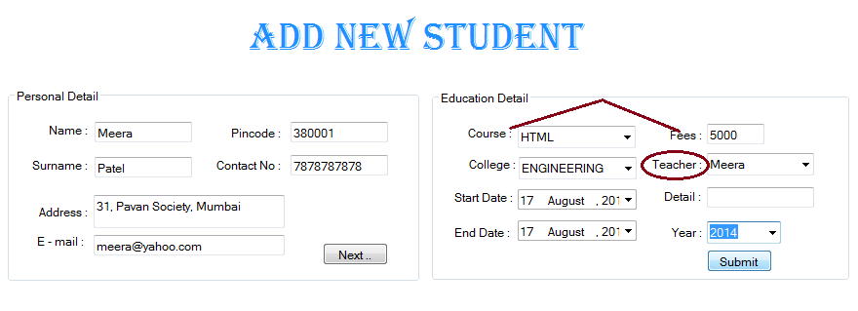

Course Management Page:

Developed a module to manage courses, assign students to subjects, and update course details. Backend queries ensured real-time updates.

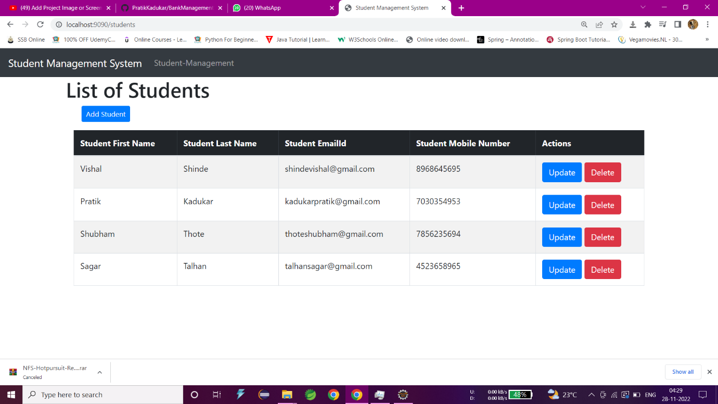

Outcome:

The project successfully demonstrated my ability to integrate Java backend logic with database operations and deliver a functional student management system. It included secure login, dynamic dashboards, student registration, course management, and reporting modules. This implementation gave me hands-on experience in enterprise-level backend development and prepared me for real-world challenges in software engineering.

9. Overall Experience
The Java Development Internship at Codec Technologies was a highly valuable and transformative learning experience that provided me with practical exposure to backend software development. During this internship, I gained hands-on knowledge of Core Java, JDBC, Servlets, JSP, and Spring Boot, which allowed me to design and implement real-world applications. I learned how to build secure login systems, manage database operations, and develop RESTful APIs that connected seamlessly with frontend interfaces.
This internship helped me strengthen my problem-solving skills, debugging techniques, and understanding of enterprise workflows. I became proficient in using version control systems like Git/GitHub, participated in Agile practices such as daily stand-ups and sprint planning, and collaborated effectively with team members on shared projects.
10.Faculty Mentor’s Remarks

This is to certify that the internship report submitted by Dasara Sai Ram has been reviewed, and it is evident that the internship was undertaken at a bona fide organization. The work documented is satisfactory, relevant to the student’s field of study, and demonstrates meaningful learning outcomes in Java backend development. The student has shown commendable progress in technical skills, project implementation, and professional conduct during the internship.

Faculty:
Signature:
Date:

